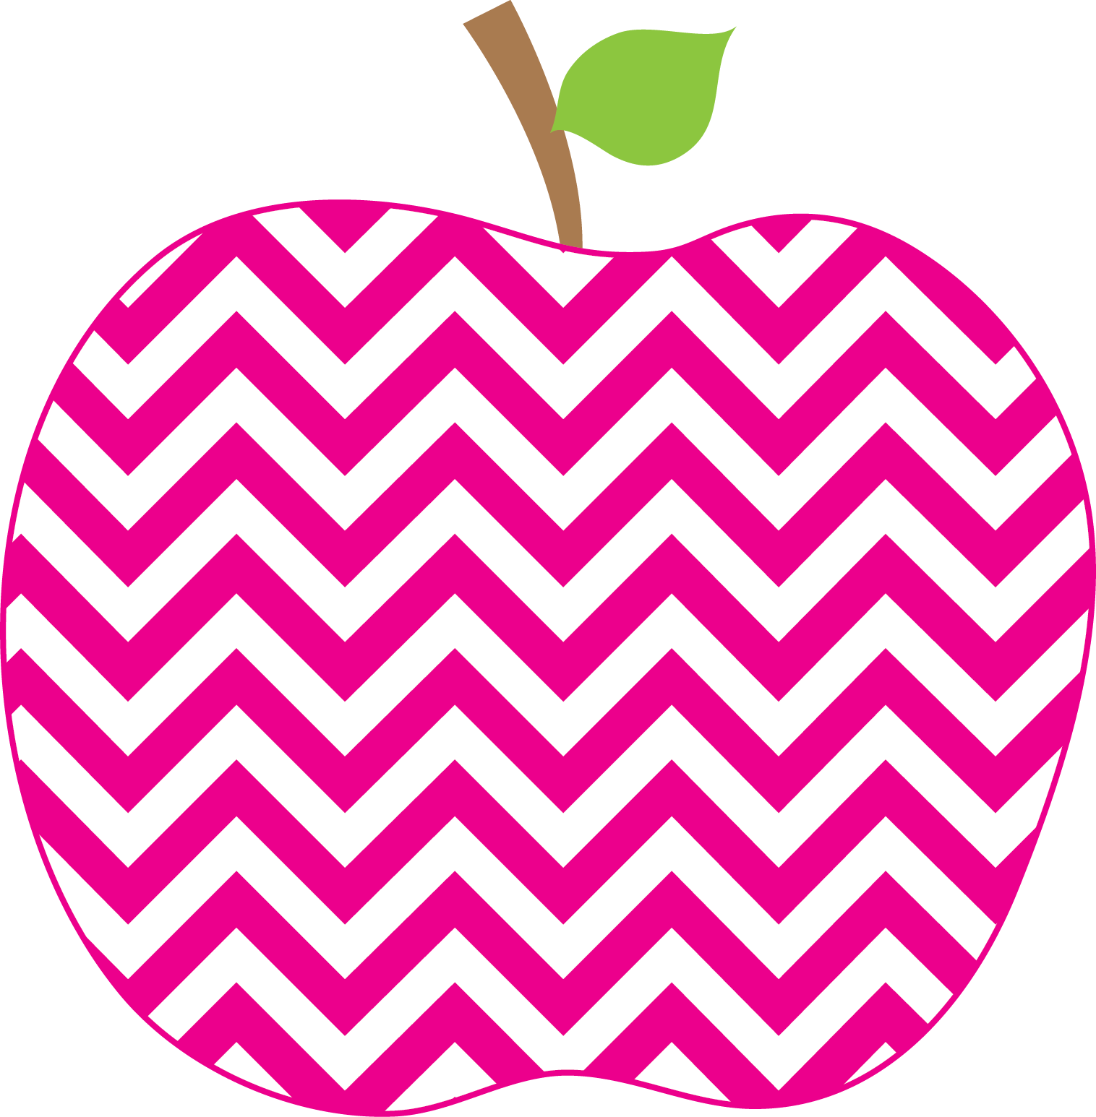

A recent Stanford study showed that recess is a profoundly important part of the school day. Organized recess programs engage students in meaningful play and prepare them to learn once back in the classroom. We will be going on the playground or for a walk outside daily. Please make sure your student is prepared by sending them to school with a sweatshirt/jacket and appropriate shoes.

Our class website is up and running! You can find “The Zacher Monthly” under on the Drake School Website.

Simply go to ntschools.org, click on “Drake School”, click “Teacher Pages”, click “Zacher, C’”, and click “Newsletters”.

**October 21 – Fall Fest 6pm-9pm**

**October 24-31 - Red Ribbon Week**

**October 28 – Town Meeting @ 9:30 am**

**October 31 – Halloween Party and 1/3 Day**

**November 6- Day Light Savings**

**November 15 – Friends of Drake Meeting @ 6:30pm**

**November 30 – ½ Day Parent Teacher Conferences**

Upcoming Events

Please Note

This Months Focus

**Reading**- Reading- Daily 5 will hopefully be in full swing next week, with students completing all rotations independently. Guided Reading groups will begin soon. We have been focusing on a book per week and different reading, grammar, and writing skills associated with each theme. Ask your child about the books they have been reading during Literacy block and which one is their favorite so far!

**Writing-** Writing is one of the components that students will be doing daily. Our Writing Workshop has begun and we will be starting Narrative writing in November. Be sure to ask your child how we begin writing each day!

**Math-** - We have started our topic on subtraction. This proves to be a more difficult challenge than learning addition facts. However, our best strategy to use when fluently doing subtraction facts is to think of the related addition fact. We have practiced using our doubles addition facts to help us with the related subtraction problem. We finished topic 3 and took the topic test. We will begin topic 4 next week which focuses on repeated addition. This skill will prep students for the concept of multiplication and builds an immense amount of number sense.

We have been working on addition (joining) and subtraction (separating) using our story problems and part-part whole mats. I encourage students to look for important math words (in all, left, altogether….)

**Social Studies/Science-**This week was Fire Prevention Week. We were lucky to hear a presentation from local Firefighters. They reminded us about safe and unsafe fire situations, as well as practicing stop, drop and roll, using the back of our hand to feel if the door is hot, and crawling low to the ground when escaping a smoky room. Please review your fire escape plan at home. In science we have been studying living and no living things. We have discussed the difference between birds and mammals, as well as reptiles, amphibians and fish.

**Spelling –** Remember to use the “Speller’s Choice Menu” items for extra credit!

**Handwriting** – We have been practicing our handwriting each day. This is a life skill and students should be practicing using proper writing skills such as capital letter when appropriate and writing their **first and LAST name**. Please reinforce these skills at home with your smart little one.

**\*Next week we will celebrate Red Ribbon Week – Refer to the weekly guide sent home for a list of daily celebrations**

**\*Drake School’s Pennies for Kids Escaping Drugs penny drive will go through October 28th. Thank you for your generous donations!**

Reminders

Zacher Monthly

The

**October 2016**