**Urban Sprawl Quiz**

**Directions:** *Identify the letter that best answers each question by placing it on the line of the corresponding number. You may use your notebook.*

____1. Urban sprawl is characterized by developments dependent on

1. Large families
2. Small families
3. Greenspace
4. Automobiles

____2. Which of the following is not common in the suburbs?

1. Excessive land consumption
2. High population densities
3. Lack of transportation options
4. Repetitive development

___3. Which city planner of the mid 20th century helped kick start the suburban movement?

1. Frederick Law Olmstead
2. Robert Moses
3. Anthony J Suburb
4. Jane Jacobs

___4. Which of the following is not a problem associated with urban sprawl?

1. Affordable house costs
2. Increased energy consumption
3. Increased air pollution
4. Increase in racial disparity

___5. Suburban residents tend to be _______ pounds heavier than their urban counterparts.

1. 6.3
2. 5.8
3. 10.4
4. 2.8

___6. Which of the following is not a problem associated with urban sprawl?

1. Decrease in economic disparity
2. Increase in racial disparity
3. Decrease in available greenspace
4. Increased flood risk

___7. The average size of a North American suburban home in 1950.

1. 800 sq.ft.
2. 1000 sq.ft.
3. 1500 sq.ft.
4. 2200 sq.ft.

___8. Suburbs have a high walkability rating.

1. True
2. False

___9. The leading cause of death among suburban teens is traffic accidents.

1. True
2. False

___10. Suburban neighborhoods use 3-6 times more land than medium density cities.

1. True

b. False

**Directions**: *Fill in the blank with an appropriate word or phrase that best completes the statement.*

11. Older neighborhoods and European cities have been built around the ____________________ system where houses and roads are oriented into square plots.

12. The grouping of houses and business in separate districts is called ____________________

13. In what ways have big box stores and smaller convenience stores become unfriendly to pedestrians?

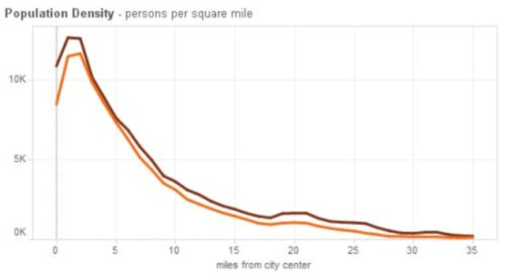14.

Explain the trend illustrated in the graph above. Why does population density increase *towards* the city center, but not increase *into* the city center?

15. In what ways has Buffalo become a more walkable city?

**Extended Response:**

Write a well thought out paragraph (6-7 sentences) on why people choose to move to the suburbs, citing multiple reasons. Explain how this affects populations of both suburban communities and city centers. (5pts)

____________________________________________________________________________________________________________________________________________________________________________________________________________________________________________________________________________________________________________________________________________________________________________________________________________________________________________________________________________________________________________________________________________________________________________________________________________________________________________________________________________________________________________________________________________________________________________________________________________________________________________________________________________________________________________________________________________________________________________________________________________________________________________________________________________________________________________________________________________________________________________________________________________________________________________________________________________________________________________________________________________________________________________________________________________________________________________________________________________________________________________________________________________________________________________________________________________________________________________________________________________________________________________________________________________________________________________________________________________________________________________________________________________________________________________________________________________________________________________________________________________________________________________________________________________________________________________________________________________________________________________________________________________________________________________________________________________________________________________________________________________________________________________________________________________________________________________________________________________