Badminton Study Guide

HISTORY:

* A very long history for one of the Olympics newest sports! Badminton took its name from Badminton House in Gloucestershire, the ancestral home of the Duke of Beaufort, where the sport was played in the last century. Modern history of badminton began in India with a game known as Poona. Gloucestershire is now the base for the International Badminton Federation. Badminton first appeared as an Olympic sport at the 1992 games in Barcelona, Spain.

RULES OF THE GAME:

* The first serve of the game always begins in the right service box.
* The serve must go diagonally into the service box across the net and only the player in that service box may return the serve.
* The receiving player returns the shuttle and it is hit back and forth until someone fails to return it successfully.
* Games are played to 21 and rally scoring is used. The team winning the rally scores the point.
* When the serving team wins the rally, they earn a point. They switch service boxes and serve again. The same player serves.
* When the receiving team wins a rally, they gain a point and the right to serve.
* When you win the serve and your score is zero or an even number, the player in the right service box serves. If your score is an odd number the player in the left service box serves.
* You may not reach over the net in order to hit the birdie.
* The serve must be hit underhand and below the waist
* The shuttle may only be hit once per side.
* A shuttle landing on the boundary line is considered in bounds and good.
* The net is 5 feet high

FAULTS:

* The wrong player returns the serve
* A shuttle falls outside of the boundaries

The shuttle fails to go over the net and/or goes through the net.

* Striking the shuttle before it crosses the net
* Touching the net with the racquet or any part of the body/clothing

IN-CLASS MODIFICATIONS/RULES:

* If the birdie hits the walls, basketball backboard or ceiling, it is out of bounds.
* All blue lines are Badminton lines
* The back boundary line is red
* On the middle court only, the sideline for doubles is blue/white.

KEY TERMS:

* Serve – Starts the game, must be done underhand.
* Drive – A hard hit, fast shot that is parallel to the ground, used to drive your opponent to the back of her court
* Smash – The “kill” shot. A hard, fast downward shot, very difficult to return.
* Drop – A shot hit softly, dropping it quickly just over and close to the net.
* Clear – A defensive shot hit high and deep into the back of the opponents court
* Ace – A fair serve that an opponent is unable to hit
* Backcourt – The half of the playing area that is further away from the net.
* Fault – An infraction of the rules resulting in loss of serve if committed by the

server or loss of point if committed by the receiver

* Inning – When all players have had a turn at serving.
* Let – An unforeseen circumstance that interferes with play. No penalty is assessed

and the point is replayed

* Match – A match consists of three games
* Shuttlecock – commonly called a shuttle or birdie, the object hit by the players

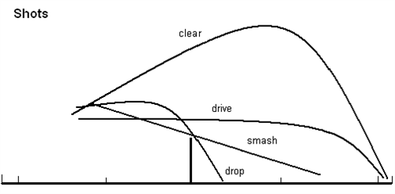

DIAGRAMS:

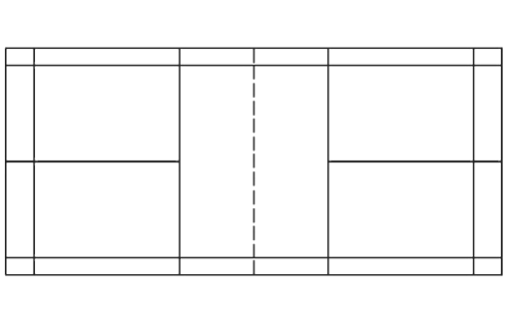

Short Service Line

Left

Service

Box

Right

Service

Box

Long Service Line

-Singles

Back Boundary Line

Long Service Line

- Doubles

Left

Service

Box

Right

Service

Box

Singles Sideline

Center Line

Doubles Sideline

Net